

Practices for Secure Software Report

Table of Contents
Document Revision History 3
Client 3
Instructions 3
Developer 4
1. Algorithm Cipher 4
2. Certificate Generation 4
3. Deploy Cipher 4
4. Secure Communications 4
5. Secondary Testing 4
6. Functional Testing 4
7. Summary 4
8. Industry Standard Best Practices 4

Document Revision History

Version | Date | Author | Comments
1.0 | [Date] | [Your Name]

Client



Instructions

Submit this completed practices for secure software report. Replace the bracketed text with the relevant information. You must document your process for writing secure communications and refactoring code that complies with software security testing protocols.

- Respond to the steps outlined below and include your findings.
- Respond using your own words. You may also choose to include images or supporting materials. If you include them, make certain to insert them in all the relevant locations in the document.
- Refer to the Project Two Guidelines and Rubric for more detailed instructions about each section of the template.

Developer
Ian Tomasiak

Algorithm Cipher

SHA-256 (Secure Hash Algorithm 256-bit)
For this project, the SHA-256 (Secure Hash Algorithm 256-bit) cryptographic hash function was selected to implement file verification and checksum validation. SHA-256 is part of the SHA-2 family of cryptographic hash functions and produces a fixed 256-bit (64 hexadecimal character) output. It is widely accepted as secure and is used in modern security applications, including TLS, digital signatures, and blockchain technologies.
SHA-256 is a one-way hash function, meaning the original input data cannot be reconstructed from the hash output. It provides collision resistance, making it computationally infeasible for two different inputs to produce the same hash value. This property is essential for ensuring data integrity during transmission.
Unlike symmetric encryption (which uses the same key for encryption and decryption) or asymmetric encryption (which uses public/private key pairs), SHA-256 does not use encryption keys. Instead, it generates a unique fingerprint of the data. This makes it ideal for checksum verification purposes, where the goal is to verify integrity rather than to encrypt and decrypt data.
Historically, earlier hash functions such as MD5 and SHA-1 were widely used but have since been deprecated due to discovered vulnerabilities and collision attacks. SHA-256 remains a secure and industry-standard choice for cryptographic hashing.

Certificate Generation
Insert a screenshot below of the CER file.

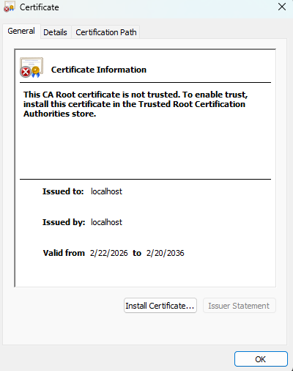

Deploy Cipher
Insert a screenshot below of the checksum verification.

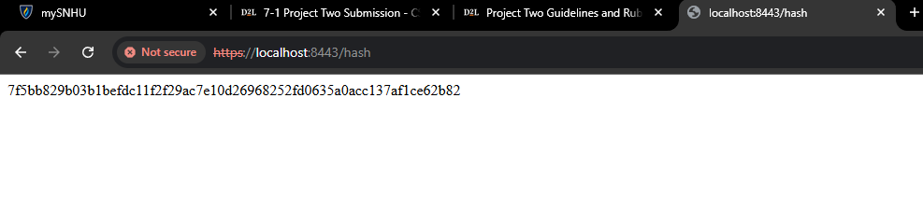

Secure Communications
Insert a screenshot below of the web browser that shows a secure webpage.



Secondary Testing
Insert screenshots below of the refactored code executed without errors and the dependency-check report.

OWASP Dependency Check was used as a static analysis tool to identify known vulnerabilities in third-party dependencies. The scan analyzed all project dependencies defined in the pom.xml file.
The report identified vulnerabilities within transitive dependencies associated with the older Spring Boot framework version included in the starter project. No new vulnerabilities were introduced as a result of the refactoring process.
The dependency-check report demonstrates that the application was analyzed using industry-standard security testing tools and that the refactored code complies with secure development practices.
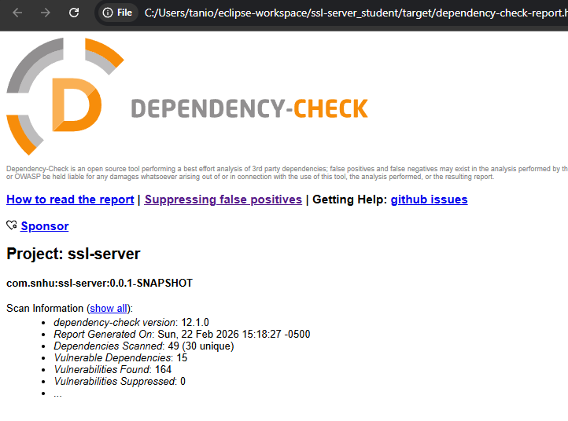
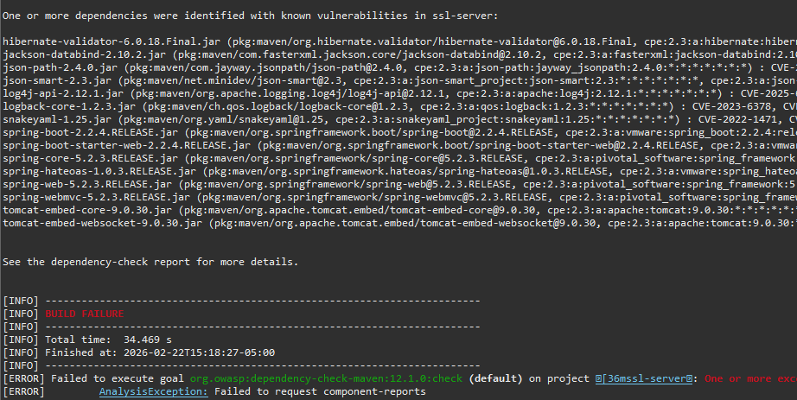

Functional Testing
Insert a screenshot below of the refactored code executed without errors.

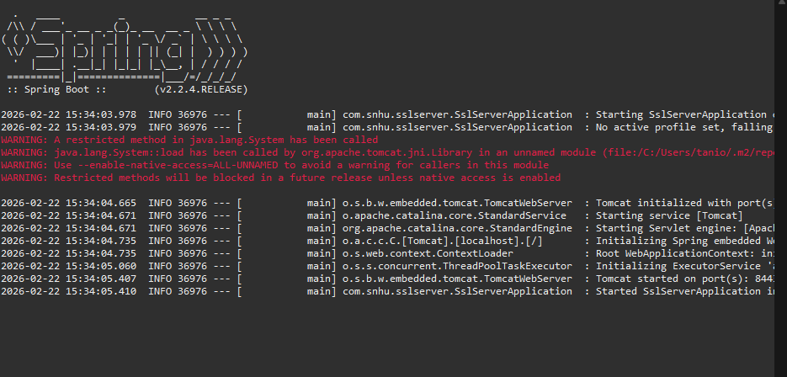

Summary
Following the Vulnerability Assessment Process Flow, multiple layers of security were implemented within the application.
Architecture Review: The application structure was reviewed prior to refactoring to identify areas requiring cryptographic enhancement.
Input Validation and APIs: The newly created endpoint was structured to handle static input securely and avoid unsafe data handling.
Cryptography: SHA-256 was implemented to ensure secure data verification and checksum validation.
Client/Server Security: The application was upgraded from HTTP to HTTPS using TLS encryption and a self-signed certificate.
Code Quality and Encapsulation: Cryptographic logic was isolated within a dedicated method to maintain secure coding standards and improve maintainability.
Static Testing and Manual Review: OWASP Dependency-Check was executed to analyze third-party dependencies for known vulnerabilities, and manual code review ensured no insecure coding practices were introduced.
Multiple layers of security were added, including transport-layer encryption, cryptographic hashing, dependency analysis, and manual review. These layers collectively strengthen the application’s security posture.

Industry Standard Best Practices

Industry standard best practices were applied throughout the refactoring process, including:
- Use of strong cryptographic hashing (SHA-256)
- TLS-secured communication (HTTPS)
- Secure certificate management
- Static dependency vulnerability analysis
- Avoidance of deprecated cryptographic algorithms
- Encapsulation of security-related logic
- Separation of concerns within application structure
Applying secure coding best practices protects Artemis Financial’s client data, maintains customer trust, and reduces the risk of security breaches. Implementing layered security and proactive vulnerability assessment contributes to the organization’s long-term operational stability and compliance with modern security standards.

